Booking for the LTG Conference 2 – 4 June 2023
Booking for the LTG Conference is through the Spektrix Booking system. You can book for two days or three days. Book before 12 noon on 14 May, for the early bird booking rates - £48 for Fri/Sat/Sun and £45 for Sat/Sun. Book after 12 noon on 14 May and the prices rise to £59 for Fri/Sat/Sun and £54 for Sat/Sun. No reimbursement will be made for a booking cancelled later than 12 noon on Friday 26 May.
In the case of difficulty please contact Anne Gilmour – secretary@littletheatreguild.org / 07971 47 47 21. The box office is not staffed throughout the day.
- After you click on the link in the Questors Microsite, the first screen you see is below – click on ‘Book now’.
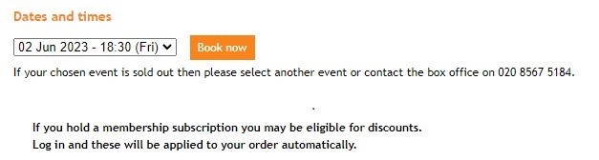
- The second screen you see is this below. If you are booking for three days click on the first box, for two days only, click on the second box. You can book for more than one person, but the booking will only appear under your name. Make your choice and click on ‘Continue’
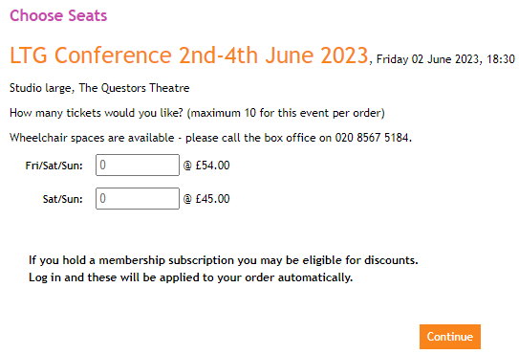
- The third screen below enables you to check if you have booked correctly. Ignore the paragraph about ‘Savings’. Once you are OK with your booking click on ‘Checkout’.
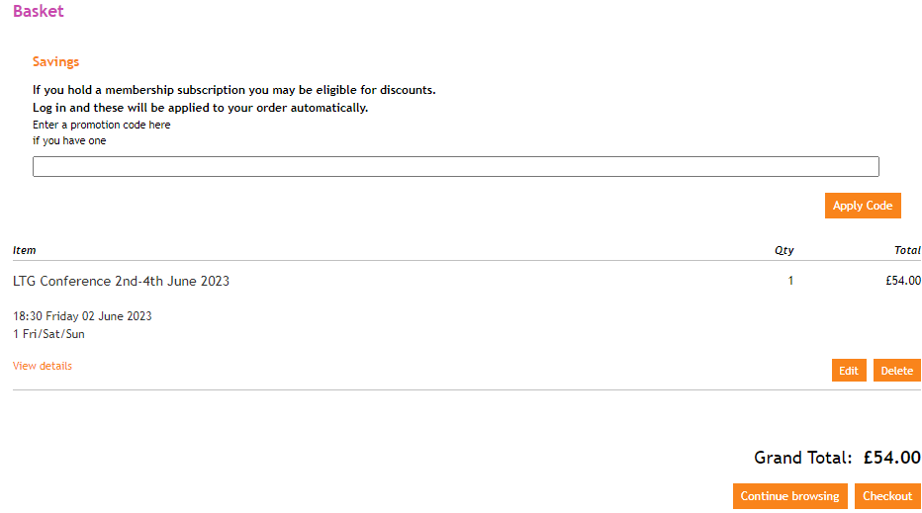
- The fourth screen is where you will need to REGISTER on the Spektrix system to complete the booking. Click on ‘Register now’ and you will be taken to another screen and asked to enter your name, email phone number, and to create a password. Click on ‘Next and (I think) you will be taken to this screen to Login.
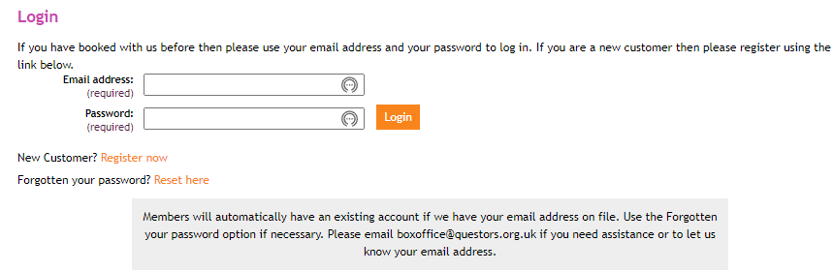
- The fifth screen confirms your booking and that your ‘tickets’ will be left at the box office. Click on ‘Continue’.
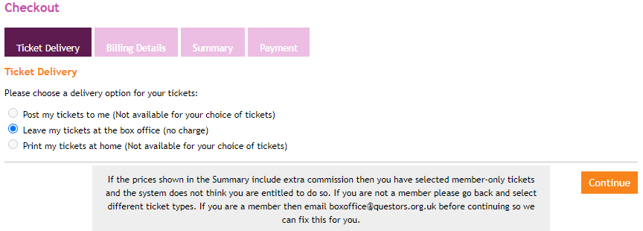
- The next screen is the Billing Details screen where you will be asked for your card details. Complete your card details and Click on ‘Continue’.
- The next screen is the Summary screen which asks you to confirm the booking that you have made and Click on ‘Continue’. You will see the text ‘You will be contacted shortly about your booking with arrangements for the conference.’
- The next screen is the Payment screen where you will be asked to complete your booking by putting your Security Code and to ‘Confirm Order’.
- The final screen, the Customer Questionnaire screen confirms that your payment has been processed and you can ‘Skip to confirmation’ where you will see a summary of your Order.

Anne Gilmour

